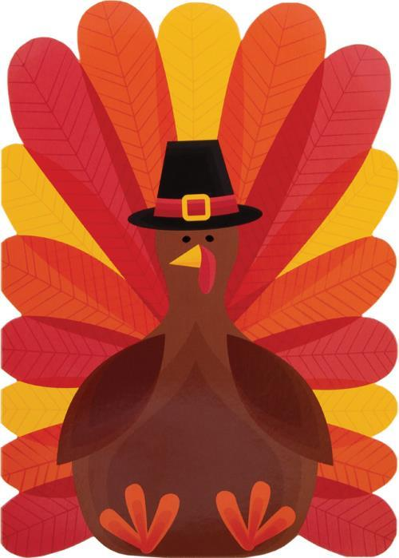**Mrs. Stephanie & Mrs. Freedom’s Newsletter**

November 3, 2023



